**TESTING METHODOLOGIES CA1**

**QN:1-**

**Code:**

**package** com.example.ca1;

**import** org.openqa.selenium.By;

**import** org.openqa.selenium.WebDriver;

**import** org.openqa.selenium.edge.EdgeDriver;

**import** io.github.bonigarcia.wdm.WebDriverManager;

**public** **class** question1

{

**public** **static** **void** main( String[] args ) **throws** InterruptedException

{

WebDriverManager.*edgedriver*().setup();

WebDriver driver = **new** EdgeDriver();

driver.get("https://www.amazon.in/ASUS-15-6-inch-GeForce-Windows-FA506IHRZ-HN111W/dp/B0B5DZTNZQ?ref_=Oct_DLandingS_D_6c1a28b8_61");

driver.manage().window().maximize();

String title = driver.getTitle();

String webtitle = "ASUS TUF Gaming A15, 15.6-inch (39.62 cms) FHD 144Hz, AMD Ryzen 5 4600H, 4GB NVIDIA GeForce GTX 1650, Gaming Laptop (8GB/512GB SSD/Windows 11/Black/2.3 Kg), FA506IHRZ-HN111W : Amazon.in: Computers & Accessories";

System.***out***.println(title);

**if**(title.equals(webtitle)) {

System.***out***.println("The title matches with the webTitle");

}

**else** {

System.***out***.println("The title doesn't match with the WebTitle");

}

driver.findElement(By.*xpath*("//*[@id=\"add-to-cart-button\"]")).click();

Thread.*sleep*(5000);

Boolean present = driver.findElement(By.*xpath*("//*[@id=\"attach-close_sideSheet-link\"]")).isDisplayed();

System.***out***.println("Is item added to cart:" + present);

driver.get("https://www.amazon.in/gp/cart/view.html/ref=dp_atch_dss_cart?");

Thread.*sleep*(5000);

driver.findElement(By.*xpath*("//*[@value=\"Delete\"]")).click();

Thread.*sleep*(2000);

String remove = driver.findElement(By.*xpath*("//*[@id=\"sc-active-cart\"]/div/div[1]/div/h1")).getText();

String emptext = "Your Amazon Cart is empty.";

**if**(remove.equals(emptext)) {

System.***out***.println("Product is removed");

}

driver.get("https://www.amazon.in/ASUS-15-6-inch-GeForce-Windows-FA506IHRZ-HN111W/dp/B0B5DZTNZQ?ref_=Oct_DLandingS_D_6c1a28b8_61");

driver.findElement(By.*xpath*("//*[@id=\"add-to-cart-button\"]")).click();

Thread.*sleep*(2000);

driver.get("https://www.amazon.in/gp/cart/view.html/ref=dp_atch_dss_cart?");

Thread.*sleep*(5000);

driver.findElement(By.*xpath*("//*[@id=\"a-autoid-0-announce\"]")).click();

driver.findElement(By.*xpath*("//*[@id=\"quantity_2\"]")).click();

Thread.*sleep*(2000);

driver.findElement(By.*xpath*("//*[@name=\"proceedToRetailCheckout\"] "));

Thread.*sleep*(1000);

String sign = driver.getTitle();

System.***out***.println(sign);

String esign = "Amazon.in";

**if**(sign.equals(esign)) {

System.***out***.println("Success");

}

**else** {

System.***out***.println("Failure");

}

}

}

**Output:**

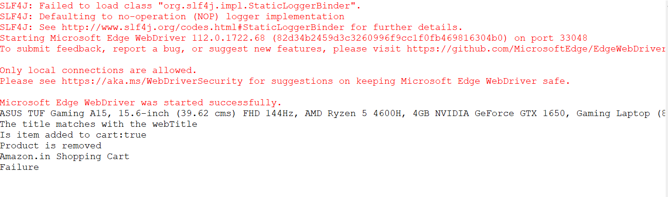

**QN:2-**

**Code:**

**package** com.example.ca1;

**import** org.openqa.selenium.By;

**import** org.openqa.selenium.WebDriver;

**import** org.openqa.selenium.WebElement;

**import** org.openqa.selenium.edge.EdgeDriver;

**import** io.github.bonigarcia.wdm.WebDriverManager;

**public** **class** question2 {

**public** **static** **void** main(String[] args) {

WebDriverManager.*edgedriver*().setup();

WebDriver driver = **new** EdgeDriver();

driver.get ("https://www.amazon.in/");

driver.manage().window().maximize() ;

String firsttitle=driver.getTitle();

System.***out***.println(firsttitle);

String newTitle="Online Shopping site in India: Shop Online for Mobiles, Books, Watches, Shoes and More - Amazon.in";

**if**(firsttitle.equals(newTitle)) {

System.***out***.println("The firstTitle matches with newTitle");

}

**else** {

System.***out***.println("The firstTitle doesn't matches with newTitle");

}

WebElement text1=driver.findElement(By.*xpath*("//*[@id=\"twotabsearchtextbox\"]"));

text1.sendKeys("macbook");

driver.findElement(By.*xpath*("//*[@id=\"nav-search-submit-button\"]")).click();

String text1=driver.findElement(By.*xpath*("//*[@id=\"search\"]/div[1]/div[1]/div/span[1]/div[1]/div[3]/div/div/div/div/div/div/div/div[2]/div/div/div[1]/h2/a/span")).getText();

System.***out***.println(text1);

String text2=driver.findElement(By.*xpath*("//*[@id=\"search\"]/div[1]/div[1]/div/span[1]/div[1]/div[4]/div/div/div/div/div/div/div/div[2]/div/div/div[1]/h2/a/span")).getText();

System.***out***.println(text2);

String text3=driver.findElement(By.*xpath*("//*[@id=\"search\"]/div[1]/div[1]/div/span[1]/div[1]/div[5]/div/div/div/div/div/div[2]/div/div/div[1]/h2/a/span")).getText();

System.***out***.println(text3);

String text4=driver.findElement(By.*xpath*("//*[@id=\"search\"]/div[1]/div[1]/div/span[1]/div[1]/div[6]/div/div/div/div/div/div[2]/div/div/div[1]/h2/a/span")).getText();

System.***out***.println(text4);

String text5=driver.findElement(By.*xpath*("//*[@id=\"search\"]/div[1]/div[1]/div/span[1]/div[1]/div[7]/div/div/div/div/div/div[2]/div/div/div[1]/h2/a/span")).getText();

System.***out***.println(text5);

//filter

driver.findElement(By.*xpath*("//*[@id=\"p_36/7252032031\"]/span/a/span")).click();

driver.findElement(By.*xpath*("//*[@id=\"p_n_pattern_browse-bin/1464446031\"]/span/a/span")).click();

}

}

**Output:**

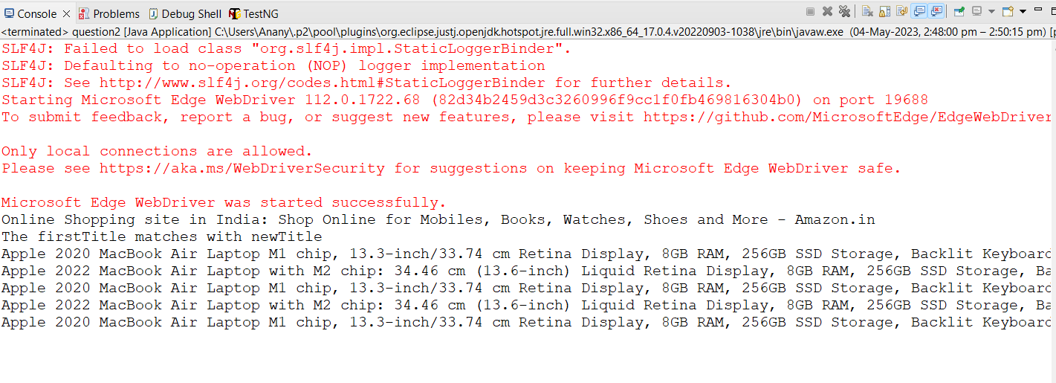

**QN:3-**

**Code:**

**package** com.example.ca1;

**import** org.openqa.selenium.By;

**import** org.openqa.selenium.WebDriver;

**import** org.openqa.selenium.WebElement;

**import** org.openqa.selenium.edge.EdgeDriver;

**import** io.github.bonigarcia.wdm.WebDriverManager;

**public** **class** question3{

**public** **static** **void** main(String[] args) {

WebDriverManager.*edgedriver*().setup();

WebDriver driver = **new** EdgeDriver();

driver.get ("https://www.amazon.in/");

driver.manage().window().maximize() ;

String Title=driver.getTitle();

System.***out***.println(Title);

String new="Online Shopping site in India: Shop Online for Mobiles, Books, Watches, Shoes and More - Amazon.in";

**if**(Title.equals(new)) {

System.***out***.println("The title matches with the newtitle");

}

**else** {

System.***out***.println("The title matches with the newtitle");

}

driver.findElement(By.*xpath*("//*[@id=\"nav-link-accountList\"]")).click();

WebElement box1=driver.findElement(By.*xpath*("//*[@id=\"ap_email\"]"));

box1.sendKeys("");

driver.findElement(By.*xpath*("//*[@id=\"continue\"]")).click();

WebElement box2=driver.findElement(By.*xpath*("//*[@id=\"ap_password\"]"));

box2.sendKeys("");

driver.findElement(By.*xpath*("//*[@id=\"signInSubmit\"]")).click();

driver.findElement(By.*xpath*("//*[@id=\"nav-link-accountList\"]")).click();

driver.findElement(By.*xpath*("//*[@id=\"a-page\"]/div[2]/div/div[2]/div[1]/a/div/div")).click();

driver.findElement(By.*xpath*("//*[@id=\"a-autoid-2-announce\"]")).click();

driver.findElement(By.*xpath*("//*[@id=\"ordersInPackage-container\"]/div/div/a[1]")).click();

}

}

**Output:**

